**PRGRAM 1-DAY TRAINING in BEE KEEPING (Experiential Learning)**

**DATED September 27, 2024: 11.00 am onwards**

**VENUE Dept pf Zoology, Hislop College, Nagpur**

**NOTICE** 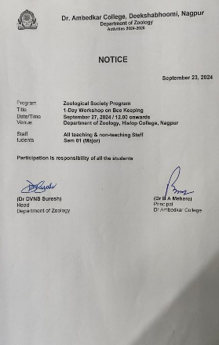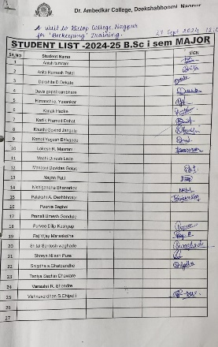

**STUDENTS 21 (Sem 01)**

**STAFF Dr DVNS Suresh, Dr A A Meshram, Dr S T Borkar & Mr O N Bhoyar**

**REPORT**

Our sem01 students have attended one day training program in beekeeping at Hislop College, Nagpur. It was a collaborative efforts of Hislop College, Dr Ambedkar College and Sindhu Mahavidyalaya for their students.**Dr Ashish Kumar** **Jha** and his team successfully conducted the training in necessary aspects of beekeeping. Introductory lecture , Bee morphometry, Foundation & frame preparation was demonstrated by his team member Ms Shreya. Ms sigdha putforth her feedback before everyone and Mr Anish presented the thanks note.

**GLIMPSES**

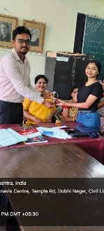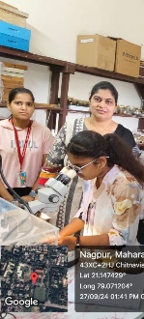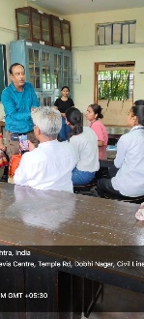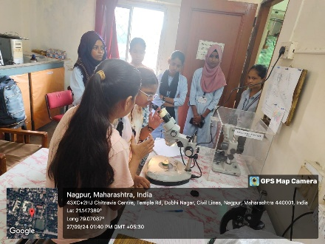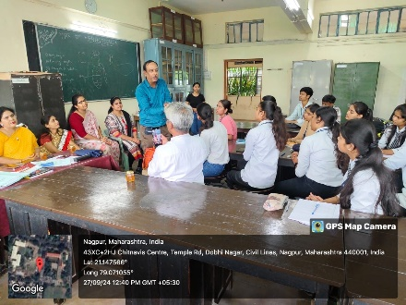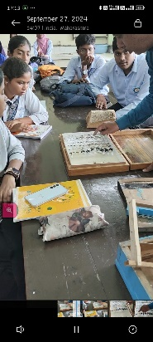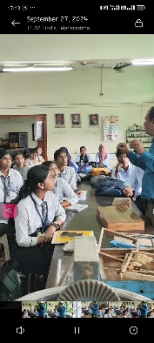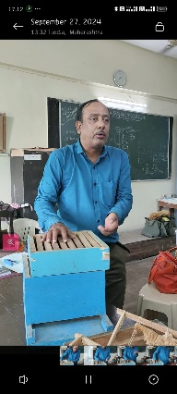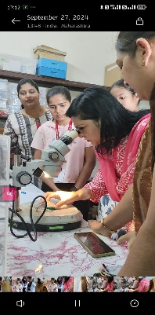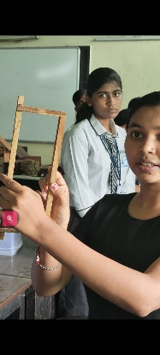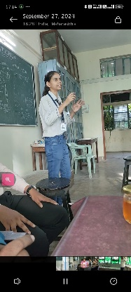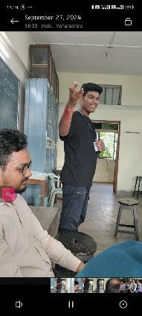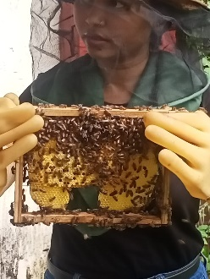

**OUTCOME To help them enrich subject content**

**To learn from others experiences & expertise**

**LINKS** Report Link kee<https://www.instagram.com/reel/DAbozuDCyl_/?igsh=eXl1dGJ5cWxkczZh>

Feedback Link <https://docs.google.com/spreadsheets/d/1laFxqYKMKFdvuQhMBPYPwz6YX9A5IhQxugCOe23e3VM/edit?resourcekey=&gid=2125835720#gid=2125835720>